Quicksort Algorithm: Implementation, Analysis, and Randomization
Assignment 5
Data Structures and Algorithms
Name: Komalben Suthar
Student ID: 005004768

1. Deterministic Quicksort Implementation
Quicksort is a divide-and-conquer sorting algorithm. It selects a pivot element, partitions the array into elements smaller and larger than the pivot, and recursively sorts the subarrays.
In the deterministic version, the first element is selected as the pivot.
Steps:
- Select pivot
- Partition array around pivot
- Recursively sort left and right subarrays

2. Performance Analysis

Best Case: O(n log n)
Occurs when the pivot divides the array into two equal halves each time.
Recurrence relation:
T(n) = 2T(n/2) + O(n)
Solving gives:
T(n) = O(n log n)

Average Case: O(n log n)
On average, the pivot splits the array reasonably evenly.
Expected recurrence:
T(n) = T(k) + T(n-k-1) + O(n)
Taking expectation over all k gives O(n log n).

Worst Case: O(n²)
Occurs when pivot is always smallest or largest element.
Example:
- Already sorted array
- Reverse sorted array
Recurrence:
T(n) = T(n-1) + O(n)
Solving gives:
T(n) = O(n²)

3. Space Complexity
- In-place sorting
- Recursive stack depth:
  - Best/Average: O(log n)
  - Worst: O(n)
Thus space complexity depends on recursion depth.

4. Randomized Quicksort
In randomized Quicksort, the pivot is chosen randomly from the subarray.
This removes dependency on input ordering.
Even if the input is sorted, pivot selection is random, making worst-case extremely unlikely.
Expected time complexity:
O(n log n)
Randomization reduces the probability of repeatedly selecting poor pivots.

5. Empirical Results
Output:
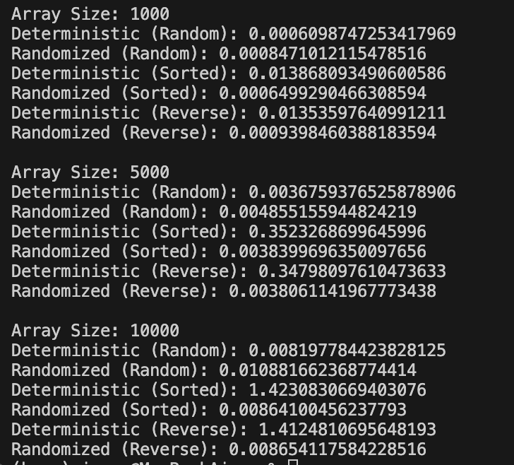
Observation:
- Deterministic Quicksort performs poorly on sorted and reverse-sorted arrays.
- Randomized Quicksort performs consistently across all distributions.
- On random data, both perform similarly.
- Randomization significantly reduces risk of worst-case behavior.

6. Practical Applications
Quicksort is widely used in:
- Database query engines
- Search algorithms
- Distributed data systems
- Embedded systems where memory efficiency matters
Randomized Quicksort is especially useful in large-scale systems where worst-case performance must be minimized.
GitHub Repository
https://github.com/kranti151/MSCS532_Assignment-5

